Graphing Linear Relations
A.
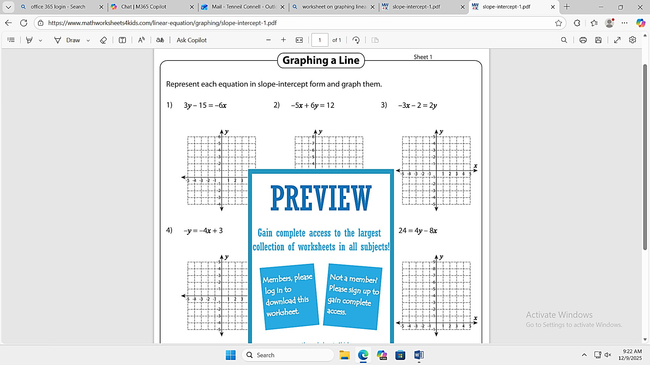

4) $-y=-4x+3$ | 5) $24=4y-8x$ | 6) $-10=6x+5y$

B. Graphing Horizontal and Vertical lines
7) $x=3$ | 8) $y=5$ | 9) $x=-4$
10) $y=-2$ | 11) $y=1$ | 12) $x=4$

C. Matching equation to graph
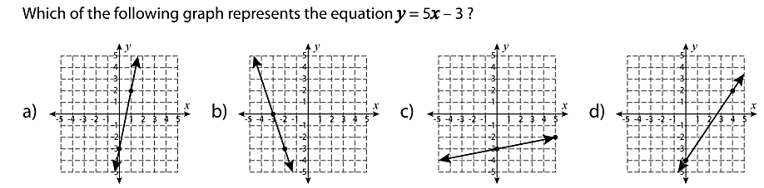

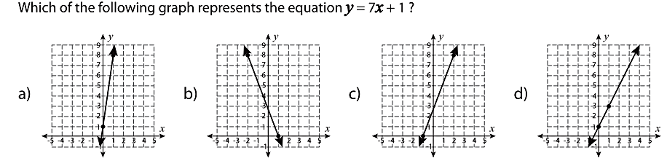

D. Matching Graph to Equation
